apiVersion: v1

kind: Pod

metadata:

  name: javawebapppod

  labels:

    app: javawebapp

spec:

  containers:

    - name: javawebappcontainer

      image: rajeshit/javawebappweb

      ports:

        - containerPort: 8080

Absolutely! Let's break down your Kubernetes Pod manifest line by line to understand what each part does:

**🧾 Full YAML:**

apiVersion: v1

kind: Pod

metadata:

name: javawebapppod

labels:

app: javawebapp

spec:

containers:

- name: javawebappcontainer

image: rajeshit/javawebappweb

ports:

- containerPort: 8080

**🔍 Explanation:**

**apiVersion: v1**

* Specifies the version of the Kubernetes API you're using.
* v1 is the stable version for core resources like Pods, Services, etc.

**kind: Pod**

* Defines the type of Kubernetes object you're creating.
* In this case, it's a **Pod**, which is the smallest deployable unit in Kubernetes.

**metadata:**

* Contains metadata about the object.
  + name: javawebapppod
  + The name of the Pod. This must be unique within the namespace.
  + labels:
  + Key-value pairs used to organize and select resources.
  + app: javawebapp is a label that can be used to group or select this Pod later (e.g., in a Service or Deployment).

**spec:**

* Describes the desired state of the Pod.
  + containers:
  + A list of containers that will run inside the Pod.
  + You can run multiple containers in a single Pod, but here there's just one.
  + name: javawebappcontainer
    - The name of the container inside the Pod.
  + image: rajeshit/javawebappweb
    - The Docker image to use for this container.
    - Kubernetes will pull this image from Docker Hub (or another registry) and run it.
  + ports:
    - A list of ports that the container exposes.
    - containerPort: 8080 means the application inside the container listens on port 8080.

**🧠 Summary:**

This manifest defines a **single Pod** running a **Java web application** container based on the image rajeshit/javawebappweb, which listens on port 8080.

Would you like to:

* Expose this Pod using a **Service**?
* Convert it into a **Deployment** for better scalability and resilience?
* Package it into a file you can download and apply with kubectl?

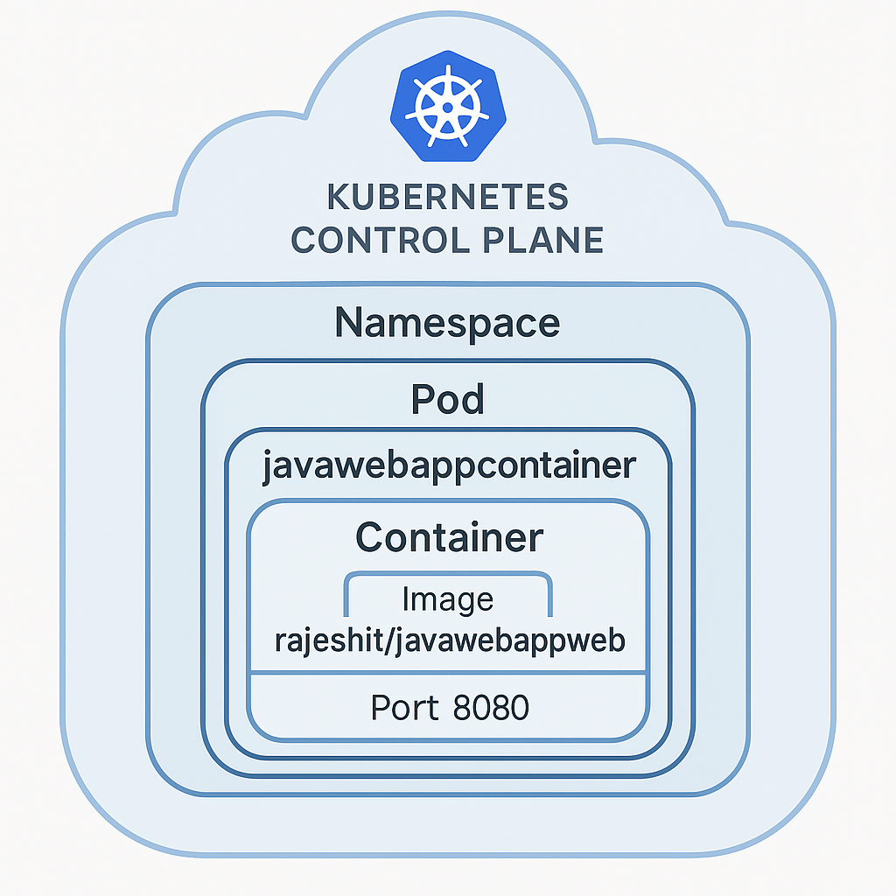­­­

After adding service

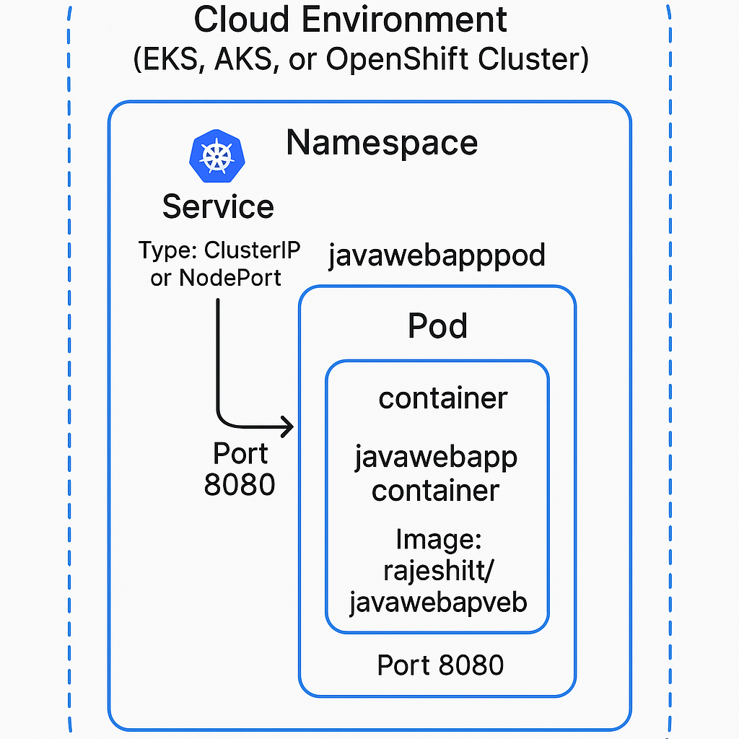

An **Ingress** in Kubernetes is a powerful resource that manages **external access** to services within a cluster, typically over HTTP or HTTPS.

**🔍 Purpose of an Ingress**

1. **Expose Services to the Internet**
   * Instead of exposing each service with a NodePort or LoadBalancer, you can use a single Ingress to route traffic to multiple services.
2. **Centralized Routing**
   * Ingress acts like a smart router. It uses rules to determine how to route incoming requests based on:
     + Hostnames (e.g., app.example.com)
     + Paths (e.g., /api, /login)
3. **TLS/SSL Termination**
   * Ingress can handle HTTPS traffic and manage SSL certificates, offloading that responsibility from your applications.
4. **Load Balancing**
   * It can distribute traffic across multiple backend Pods, improving availability and performance.
5. **Authentication and Rate Limiting**
   * With Ingress controllers like NGINX or Traefik, you can add features like basic auth, IP whitelisting, and rate limiting.

**🧠 Example Use Case**

You have two services:

* javawebapp at /
* adminapp at /admin

An Ingress can route:

* https://example.com/ → javawebapp
* https://example.com/admin → adminapp

Would you like a visual diagram showing how Ingress fits into your current setup with the Pod and Service?

the **Ingress**, **Service**, and **Pod** setup in a Kubernetes cluster.

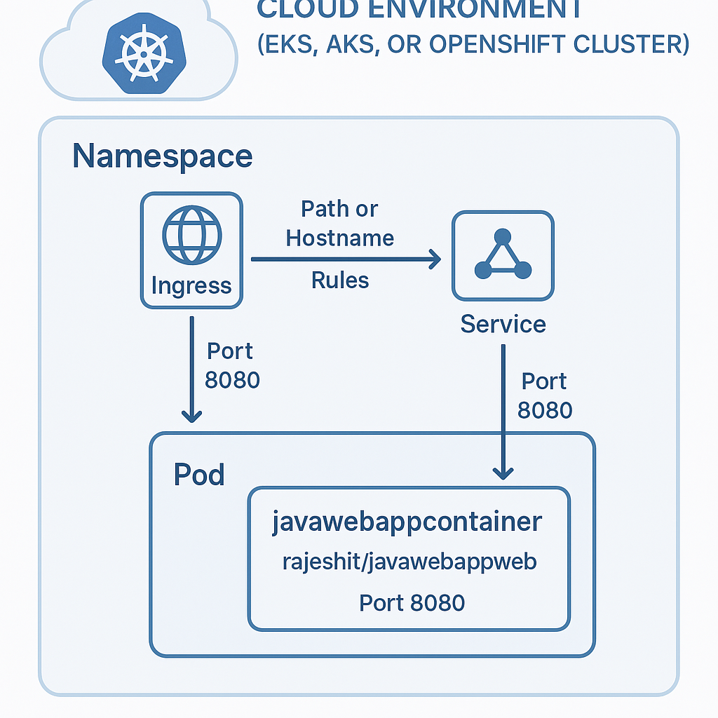

Great question! Here's a clear comparison between **Ingress** and **LoadBalancer** in Kubernetes:

**🔁 Ingress vs LoadBalancer**

| **Feature** | **Ingress** | **LoadBalancer** |
| --- | --- | --- |
| **Purpose** | Routes HTTP/HTTPS traffic to services based on rules | Exposes a service externally using a cloud provider's load balancer |
| **Layer** | Application Layer (Layer 7 - HTTP/HTTPS) | Network Layer (Layer 4 - TCP/UDP) |
| **Routing** | Supports path-based and host-based routing | Routes all traffic to a single service |
| **TLS/SSL Support** | Yes, supports SSL termination and HTTPS | No built-in SSL termination (handled by the app or external tools) |
| **Cost** | More cost-effective (one Ingress for many services) | More expensive (each LoadBalancer creates a cloud load balancer) |
| **Flexibility** | High – can route to multiple services with different rules | Low – routes to only one service |
| **Use Case** | Ideal for web apps, APIs, and microservices with complex routing needs | Simple external access to a single service |
| **Controller Needed** | Yes – requires an Ingress Controller (e.g., NGINX, Traefik, HAProxy) | No – handled by the cloud provider |

**🧠 Example Use Case**

* **Use Ingress** when:
  + You have multiple services (e.g., /api, /admin, /shop) and want to expose them under one domain.
  + You want centralized SSL management.
* **Use LoadBalancer** when:
  + You need quick, simple external access to a single service (e.g., a database or a standalone app).

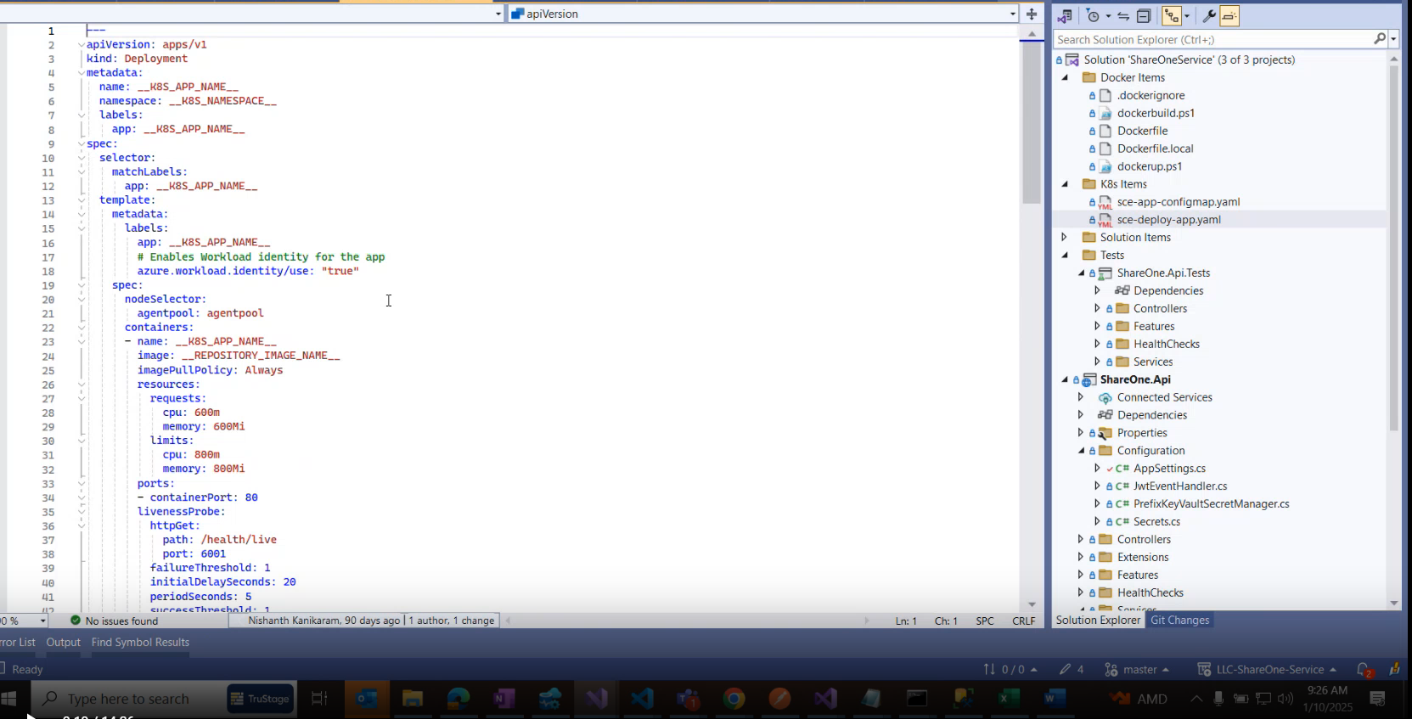

You're close, but let's clarify the behavior of **Kubernetes Services** and **Pod accessibility**:

**🔹 Pod Without a Service**

* **Accessibility**: Only accessible **within the cluster**.
* **How**: Other pods can reach it using its **Pod IP**, but this IP is **ephemeral** and not DNS-resolvable.
* **Limitation**: Not ideal for stable communication or scaling.

**🔹 Pod With a Service (Type: ClusterIP)**

* **Accessibility**: Still **only accessible within the cluster**.
* **How**: Other pods can access it using the **Service name** (DNS), which resolves to a **stable virtual IP**.
* **Use Case**: Internal communication between microservices.

**🔹 Summary of Service Types**

| **Service Type** | **Accessible From** | **Use Case** |
| --- | --- | --- |
| ClusterIP | Inside cluster only | Internal communication |
| NodePort | Inside + Outside (via Node IP + port) | Basic external access |
| LoadBalancer | Inside + Outside (via cloud load balancer) | Production-grade external access |
| ExternalName | Maps to external DNS | Redirect to external service |

**✅ So, to answer your question:**

If I created a pod with a service, and service type is ClusterIP, can I access it from outside the cluster?

**No**, ClusterIP is **not accessible from outside** the cluster. It only provides **internal access** within the cluster.

Would you like a visual diagram of how these service types work?

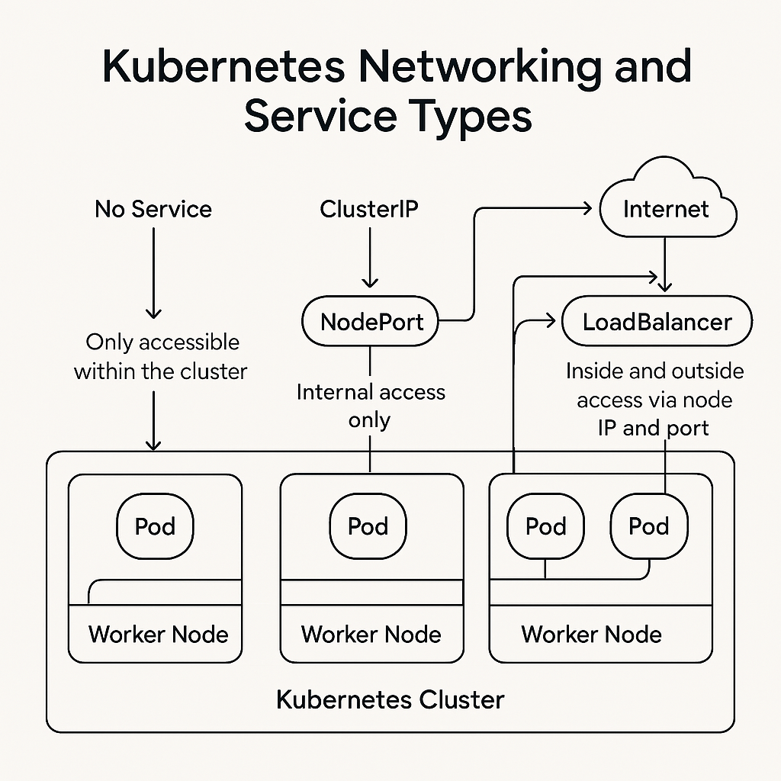

If application is not accessible from internet,  
  
or after restarting pod, pod is not coming up. So that I am checking the connectivity using clusterIP (NodePort)

Kubectl get pods

Kubectl get pods -0 wide

Here you can see pod-IP.

Kubectl get svc

Kubectl describe service javawebappsvc

curl 10.98.187.60: 32645

Using the NodePort we can access outside the cluster.

To access the outside, we can use public IP of master node.

The **LoadBalancer** service type in Kubernetes is used to expose your application **to the internet** through a **cloud provider’s external load balancer**. Here's a breakdown of its purpose and use:

**🔹 Purpose of LoadBalancer Service Type**

* **External Access**: It allows users **outside the Kubernetes cluster** (e.g., customers, clients, browsers) to access your application.
* **Automatic Provisioning**: When you create a LoadBalancer service, Kubernetes asks the cloud provider (like AWS, Azure, GCP) to **provision a load balancer** and assign it a **public IP address**.
* **Stable Endpoint**: This public IP becomes a **stable entry point** to your application.

**🔹 Use Cases**

1. **Web Applications**  
   Hosting a website or API that needs to be accessed by users over the internet.
2. **Mobile App Backends**  
   Providing a public endpoint for mobile apps to communicate with backend services.
3. **Third-party Integrations**  
   Allowing external systems to call your services via a public IP or DNS.

**🔹 How It Works**

1. You define a service with type: LoadBalancer.
2. Kubernetes provisions a cloud load balancer.
3. The load balancer forwards traffic to the service.
4. The service routes traffic to the appropriate pods.

**🔸 Example YAML**

apiVersion: v1

kind: Service

metadata:

name: my-app-service

spec:

type: LoadBalancer

selector:

app: my-app

ports:

- protocol: TCP

port: 80

targetPort: 8080

Would you like to see how this compares to NodePort or Ingress in terms of cost, flexibility, and scalability?

Here's a comparison of **LoadBalancer**, **NodePort**, and **Ingress** in terms of **cost**, **flexibility**, and **scalability**:

**🔸 1. LoadBalancer**

| **Feature** | **Description** |
| --- | --- |
| **Cost** | 💰 High — Each service creates a separate cloud load balancer (billed by cloud provider). |
| **Flexibility** | 😐 Limited — One service = one load balancer. Not ideal for many services. |
| **Scalability** | ✅ Good — Scales well with cloud-native apps, but expensive at scale. |
| **Use Case** | Exposing a few critical services directly to the internet. |

**🔸 2. NodePort**

| **Feature** | **Description** |
| --- | --- |
| **Cost** | 💸 Low — No external load balancer needed. |
| **Flexibility** | 😐 Limited — Fixed port range (30000–32767), manual IP/port management. |
| **Scalability** | 🚫 Poor — Not ideal for production or large-scale apps. |
| **Use Case** | Development, testing, or simple setups without cloud load balancers. |

**🔸 3. Ingress**

| **Feature** | **Description** |
| --- | --- |
| **Cost** | 💰 Medium — One load balancer can serve many services via routing rules. |
| **Flexibility** | ✅ High — Supports path-based and host-based routing, TLS, etc. |
| **Scalability** | ✅ Excellent — Centralized control, great for microservices. |
| **Use Case** | Production-grade apps with multiple services and domains. |

**✅ Recommendation**

| **Scenario** | **Best Option** |
| --- | --- |
| Small app, no cloud | NodePort |
| Few public services | LoadBalancer |
| Many services, production-grade | Ingress |

Would you like a visual chart comparing these three options side by side?

Requirement of DaemonSet  
  
 I want to run my pods in all the worker nodes, So we are going a concept of DaemonSet.

To collect logs, health.

Simply actuator in springboot.

Deployment

* + Rollback the deployment, i.e., the biggest advantage of Kubernetes when you go with it.

ReplicationController VS ReplicaSet 🡪 Only difference is selectors and matchLables;

DaemonSet 🡪 The copy of the will executes in all the nodes. If you have a cluster with 5 nodes, the pods will execute in all the 5 nodes.

Scale up scale down the pods is not applicable if we go with ReplicationController, ReplicaSet and DaemonSet, even with Docker Swam

In projects, we are going use DaemonSet to the execute pods which are required to be executed in every node. Like logs collector, node monitor.

For that we have use to use deployment.

ReCreate means existing pods will be deleted and new pods will be created.

Rolling Update: one by one pod will be killed and one-by-one will be created.

**Kubeadm** is a tool provided by Kubernetes to help you set up a **Kubernetes cluster** quickly and easily. It handles the complex parts of cluster bootstrapping, such as generating certificates, starting control plane components, and joining worker nodes.

**🔧 What Kubeadm Does**

* Initializes a Kubernetes **control plane** node (kubeadm init)
* Joins **worker nodes** to the cluster (kubeadm join)
* Manages **cluster certificates** and **token-based authentication**
* Supports **HA (High Availability)** setups

**🧱 Basic Workflow**

1. **Install prerequisites** on all nodes:
   * Linux OS (Ubuntu, CentOS, etc.)
   * Docker or container runtime (like containerd)
   * kubeadm, kubelet, and kubectl
2. **Initialize the control plane**:

sudo kubeadm init --pod-network-cidr=10.244.0.0/16

1. **Set up kubeconfig** for kubectl:

mkdir -p $HOME/.kube

sudo cp -i /etc/kubernetes/admin.conf $HOME/.kube/config

sudo chown $(id -u):$(id -g) $HOME/.kube/config

1. **Install a pod network add-on** (e.g., Flannel, Calico):

kubectl apply -f https://raw.githubusercontent.com/coreos/flannel/master/Documentation/kube-flannel.yml

1. **Join worker nodes** using the command output from kubeadm init:

kubeadm join <control-plane-ip>:6443 --token <token> --discovery-token-ca-cert-hash sha256:<hash>

**📌 When to Use Kubeadm**

* For **learning** and **development**
* For **custom production setups** where you want control over the infrastructure
* When using **bare metal** or **VMs** without a managed Kubernetes service

Would you like help setting up a cluster with kubeadm, or are you troubleshooting something specific?

**AppViewX**

**That’s interesting! If your old project used AppViewX for traffic distribution across network and database layers, it likely leveraged AppViewX’s ADC+ (Application Delivery Controller automation) and possibly AppACCESS+ modules.**

**Here’s how that setup might have worked:**

**🔁 Traffic Distribution via AppViewX**

**1. Application Delivery Controllers (ADC+)**

**AppViewX can automate and orchestrate ADCs like:**

* **F5 BIG-IP**
* **Citrix NetScaler**
* **A10 Networks**
* **NGINX**

**These ADCs handle:**

* **Load balancing (L4/L7)**
* **SSL offloading**
* **Health checks**
* **Traffic steering based on rules or policies**

**AppViewX provides a GUI and API to manage these configurations dynamically, reducing manual errors and improving agility.**

**2. Database Traffic Management**

**While AppViewX doesn’t directly manage databases, it can:**

* **Route traffic to database proxies/load balancers (e.g., HAProxy, ProxySQL)**
* **Automate failover and monitor health of DB endpoints**
* **Integrate with DNS and IPAM tools to update records dynamically**

**3. Self-Service Portals**

**Teams can use AppViewX to:**

* **Deploy new services with traffic policies**
* **Update routing rules without deep networking knowledge**
* **Trigger workflows for approvals and compliance**

**🧩 Example Use Case**

**Let’s say your app had:**

* **A frontend served via NGINX**
* **A backend API behind F5 BIG-IP**
* **A MySQL cluster with ProxySQL**

**AppViewX could:**

* **Automatically configure NGINX and F5 to distribute traffic**
* **Monitor backend and DB health**
* **Redirect traffic during failovers or maintenance**
* **Provide dashboards and alerts**

**Would you like a visual diagram of how this architecture might look? Or are you trying to replicate or modernize this setup in a new project?**

In **Kubernetes**, a **resource** refers to any object you can manage through the Kubernetes API. These resources represent the desired state of your cluster and are used to define workloads, networking, storage, and configuration.

**🧱 Core Kubernetes Resources**

**1. Workload Resources**

These define how applications run:

* **Pod**: The smallest deployable unit; contains one or more containers.
* **ReplicaSet**: Ensures a specified number of pod replicas are running.
* **Deployment**: Manages ReplicaSets and allows rolling updates.
* **StatefulSet**: Like Deployment, but for stateful apps (e.g., databases).
* **DaemonSet**: Ensures a pod runs on all (or some) nodes.
* **Job**: Runs a task to completion.
* **CronJob**: Runs jobs on a schedule.

**2. Service Resources**

These expose and load balance applications:

* **Service**: Exposes a set of pods as a network service.
* **Ingress**: Manages external access to services, typically HTTP.
* **Endpoint**: Represents the IPs of the pods a service routes to.

**3. Configuration Resources**

These manage app configuration:

* **ConfigMap**: Stores non-sensitive configuration data.
* **Secret**: Stores sensitive data like passwords or tokens.

**4. Storage Resources**

These manage persistent storage:

* **PersistentVolume (PV)**: A piece of storage in the cluster.
* **PersistentVolumeClaim (PVC)**: A request for storage by a pod.
* **StorageClass**: Defines types of storage (e.g., SSD, HDD).

**5. Cluster Resources**

These manage the cluster itself:

* **Node**: A worker machine in Kubernetes.
* **Namespace**: A way to divide cluster resources between users.
* **ResourceQuota**: Limits resource usage per namespace.
* **LimitRange**: Sets default resource limits for pods/containers.

**📊 Example: A Simple Deployment**

apiVersion: apps/v1

kind: Deployment

metadata:

name: my-app

spec:

replicas: 3

selector:

matchLabels:

app: my-app

template:

metadata:

labels:

app: my-app

spec:

containers:

- name: my-container

image: nginx

This creates a **Deployment** that runs 3 replicas of an NGINX container.

Would you like a **visual diagram** of how these resources relate to each other in a typical Kubernetes setup?

**🔍 Diagram Highlights**

* **Deployment → ReplicaSet → Pod → Container**: Shows how workloads are managed and scaled.
* **Pod → ConfigMap / Secret**: Pods can mount or reference configuration and sensitive data.
* **Pod → PersistentVolumeClaim → PersistentVolume**: Illustrates how pods access persistent storage.
* **Service → Pod**: Services expose and load balance traffic to pods.
* **Ingress → Service**: Ingress routes external traffic to services.
* **Pod → Node**: Pods are scheduled to run on nodes.
* **🔍 Diagram Highlights**
* **Deployment → ReplicaSet → Pod → Container**: Shows how workloads are managed and scaled.
* **Pod → ConfigMap / Secret**: Pods can mount or reference configuration and sensitive data.
* **Pod → PersistentVolumeClaim → PersistentVolume**: Illustrates how pods access persistent storage.
* **Service → Pod**: Services expose and load balance traffic to pods.
* **Ingress → Service**: Ingress routes external traffic to services.
* **Pod → Node**: Pods are scheduled to run on nodes.

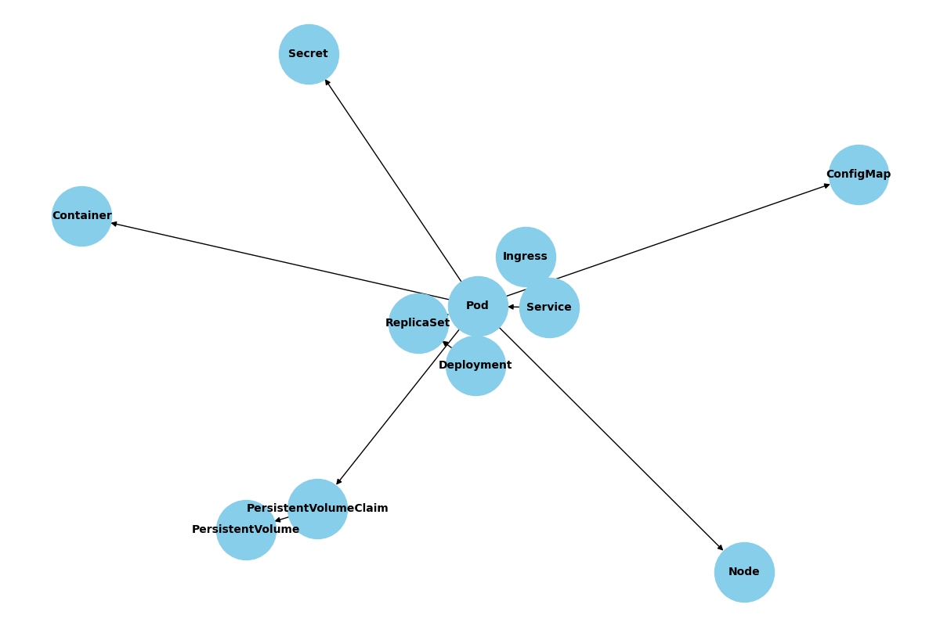

* **StatefulSet → Pod**: Manages stateful applications with stable identities and persistent storage.
* **CronJob → Job → Pod**: Automates scheduled tasks, where each CronJob creates Jobs that run Pods.
* **Job → Pod**: Represents one-off tasks that run to completion.

Note: DaemonSet will be used at **LogStash, to collect logs from all the nodes.**

Choosing an optimum AKS configuration factors in **cost of operation** and **capacity**. The cost is based on the number of nodes and the VM sizes of each.

We recommend separation of system and application workloads into dedicated node pools.

Best practices suggest minimal deployment requirements, although Microsoft suggestions seem ambiguous. [Microsoft system node pools](https://learn.microsoft.com/en-us/azure/aks/use-system-pools?tabs=azure-cli#system-and-user-node-pools)

* *"System node pools require a VM SKU of at least 4 vCPUs and 4GB memory."*
* *"A minimum of three nodes of 8 vCPUs or two nodes of at least 16 vCPUs is recommended ? (for example, Standard_DS4_v2), especially for large clusters (Multiple CoreDNS Pod replicas, 3-4+ add-ons, etc.)."*

The cluster configuration must have enough capacity to schedule your application workloads, typically defined with a min and max replica count for each deployment (application). The actual number of replicas can vary in this range based on average CPU usage for all the running pods. Your configuration should support the maximum number of replicas configured for each deployment.

Configurations should be tested under load in a non-prod environment beyond a level anticipated when running in production.

Sample VM costs per month

Values taken from [Microsoft VM Pricing](https://azure.microsoft.com/en-us/pricing/details/virtual-machines/linux/#pricing)

|  |  |  |  |  |  |  |
| --- | --- | --- | --- | --- | --- | --- |
| **VM size** | **vCPUs** | **Gb RAM** | **$monthly** | **$1 year** | **$3 year** | **notes** |
| Standard_DS2_v2 | 2 | 7 | 106 | 73 | 50 |  |
| Standard_D4as_v4 | 4 | 16 | 140 | 96 | 64 | [Titan default AKS_AGENT_VM_SIZE](https://dev.azure.com/cunamutual/SecureCloudEnablement/_git/Atlas?path=%2FInfra%2FAzureKubernetesService%2Fsrc%2FNodePools%2FaksNodePoolVariables.ps1&_a=contents&version=GBmaster) |
| Standard_DS3_v2 | 4 | 14 | 213 | 147 | 100 |  |
| Standard_F8s_v2 | 8 | 16 | 248 | 168 | 107 |  |

**Kubernetes Quotations**

**Resource Management for Pods and Containers**

**When you specify a**[**Pod**](https://kubernetes.io/docs/concepts/workloads/pods/)**, you can optionally specify how much of each resource a**[**container**](https://kubernetes.io/docs/concepts/containers/)**needs. The most common resources to specify are CPU and memory (RAM); there are others.**

**When you specify the resource *request* for containers in a Pod, the**[**kube-scheduler**](https://kubernetes.io/docs/reference/command-line-tools-reference/kube-scheduler/)**uses this information to decide which node to place the Pod on. When you specify a resource *limit* for a container, the**[**kubelet**](https://kubernetes.io/docs/reference/generated/kubelet)**enforces those limits so that the running container is not allowed to use more of that resource than the limit you set. The kubelet also reserves at least the *request* amount of that system resource specifically for that container to use**

**From <**[**https://kubernetes.io/docs/concepts/configuration/manage-resources-containers/**](https://kubernetes.io/docs/concepts/configuration/manage-resources-containers/)**>**

**1. Resource Requests and Limits**

**Kubernetes allows you to specify resource requests and limits for each container in a Pod:**

* **Requests: The minimum amount of CPU or memory guaranteed to the container.**
* **Limits: The maximum amount of CPU or memory the container is allowed to use.**

resources:

  requests:

    memory: "64Mi"

    cpu: "250m"

  limits:

    memory: "128Mi"

    cpu: "500m"

**2. Why Use Requests and Limits?**

* **Scheduling: Kubernetes uses requests to decide which node can run a Pod.**
* **Stability: Limits prevent a container from consuming excessive resources and affecting others. 3. CPU and Memory Units**
* **CPU: Measured in cores. 500m = 0.5 CPU core.**
* **Memory: Measured in bytes. Common units: Mi (mebibytes), Gi (gibibytes).**
* **Quality of Service (QoS): Kubernetes assigns a QoS class to Pods based on their resource settings:**
  + **Guaranteed: Requests = Limits for all containers.**
  + **Burstable: Requests < Limits.**
  + **BestEffort: No requests or limits set.**

**4. Best Practices**

* **Set realistic requests and limits based on performance testing.**
* **Use monitoring tools (like Prometheus + Grafana) to observe usage patterns.**
* **Avoid setting limits without requests, as it can lead to unpredictable scheduling.**
* **Use Vertical Pod Autoscaler (VPA) to automatically adjust resource requests.**
* **Use Horizontal Pod Autoscaler (HPA) to scale Pods based on CPU/memory usage or custom metrics.**

**5. Tools for Resource Management**

* **kubectl top pod/node: View current resource usage.**
* **Metrics Server: Collects resource metrics.**
* **ResourceQuota: Limits total resource usage per namespace.**
* **LimitRange: Sets default/min/max resource requests and limits per Pod/container.**

**Motivation for CPU requests and limits**

**By configuring the CPU requests and limits of the Containers that run in your cluster, you can make efficient use of the CPU resources available on your cluster Nodes. By keeping a Pod CPU request low, you give the Pod a good chance of being scheduled. By having a CPU limit that is greater than the CPU request, you accomplish two things:**

* **The Pod can have bursts of activity where it makes use of CPU resources that happen to be available.**
* **The amount of CPU resources a Pod can use during a burst is limited to some reasonable amount.**

**From <**[**https://kubernetes.io/docs/tasks/configure-pod-container/assign-cpu-resource/**](https://kubernetes.io/docs/tasks/configure-pod-container/assign-cpu-resource/)**>**

**CPU resource units**

**Limits and requests for CPU resources are measured in *cpu* units. In Kubernetes, 1 CPU unit is equivalent to 1 physical CPU core, or 1 virtual core, depending on whether the node is a physical host or a virtual machine running inside a physical machine.**

**Fractional requests are allowed. When you define a container with spec.containers[].resources.requests.cpu set to 0.5, you are requesting half as much CPU time compared to if you asked for 1.0 CPU. For CPU resource units, the**[**quantity**](https://kubernetes.io/docs/reference/kubernetes-api/common-definitions/quantity/)**expression 0.1 is equivalent to the expression 100m, which can be read as "one hundred millicpu". Some people say "one hundred millicores", and this is understood to mean the same thing.**

**CPU resource is always specified as an absolute amount of resource, never as a relative amount. For example, 500m CPU represents the roughly same amount of computing power whether that container runs on a single-core, dual-core, or 48-core machine.**

**CPU Utilization: The controller calculates the CPU utilization as a percentage of the CPU request.**[**For example, if a container has a CPU request of 200 millicores and is currently using 100 millicores, the utilization is 50%**](https://kubernetes.io/docs/tasks/run-application/horizontal-pod-autoscale/)

**Horizontal pod autoscaler**

**Kubernetes uses the horizontal pod autoscaler (HPA) to monitor the resource demand and automatically scale the number of pods. By default, the HPA checks the Metrics API every 15 seconds for any required changes in replica count, and the Metrics API retrieves data from the Kubelet every 60 seconds. So, the HPA is updated every 60 seconds. When changes are required, the number of replicas is increased or decreased accordingly. HPA works with AKS clusters that deployed the Metrics Server for Kubernetes version 1.8 and higher.**

**To minimize race events, a delay value is set. This value defines how long the HPA must wait after a scale event before another scale event can be triggered. This behavior allows the new replica count to take effect and the Metrics API to reflect the distributed workload. There's**[**no delay for scale-up events as of Kubernetes 1.12**](https://kubernetes.io/docs/tasks/run-application/horizontal-pod-autoscale/#support-for-cooldown-delay)**, however, the default delay on scale down events is *5 minutes*.**

**From <**[**https://learn.microsoft.com/en-us/azure/aks/concepts-scale#horizontal-pod-autoscaler**](https://learn.microsoft.com/en-us/azure/aks/concepts-scale#horizontal-pod-autoscaler)**>**

**How users connect to an application**

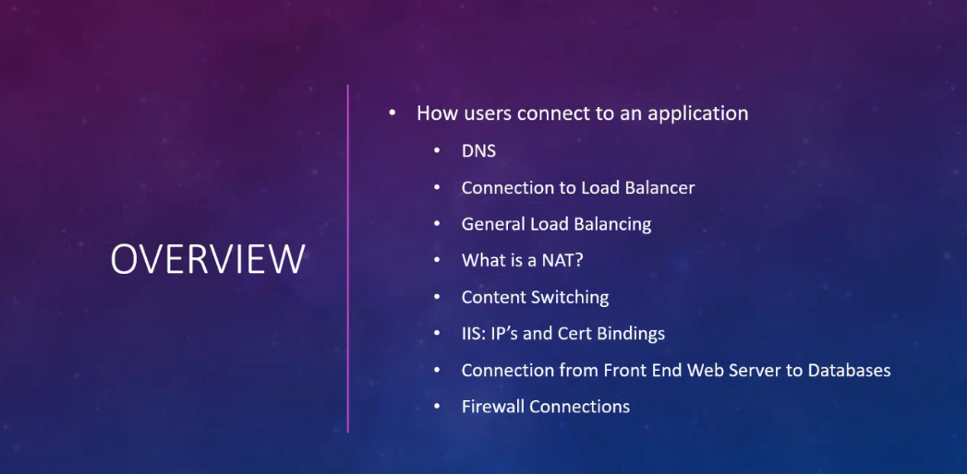

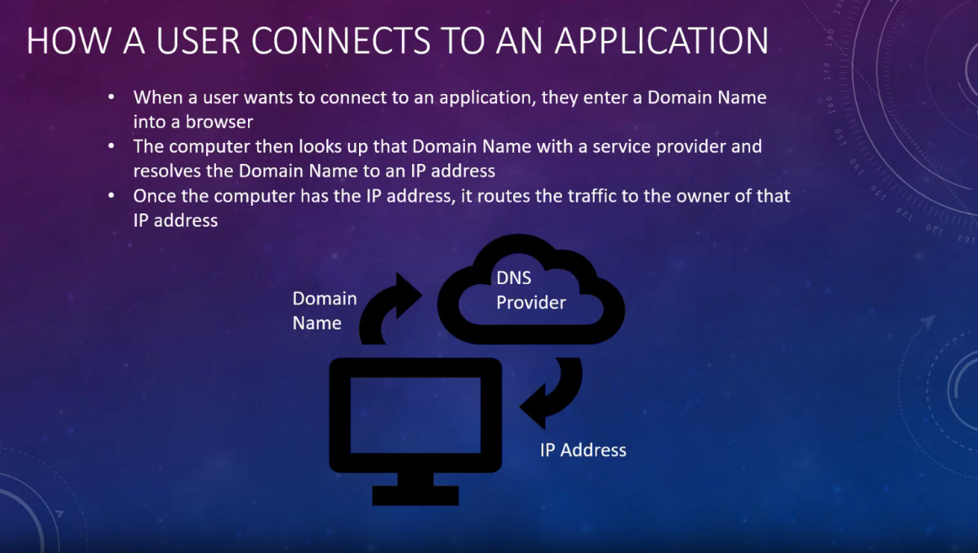

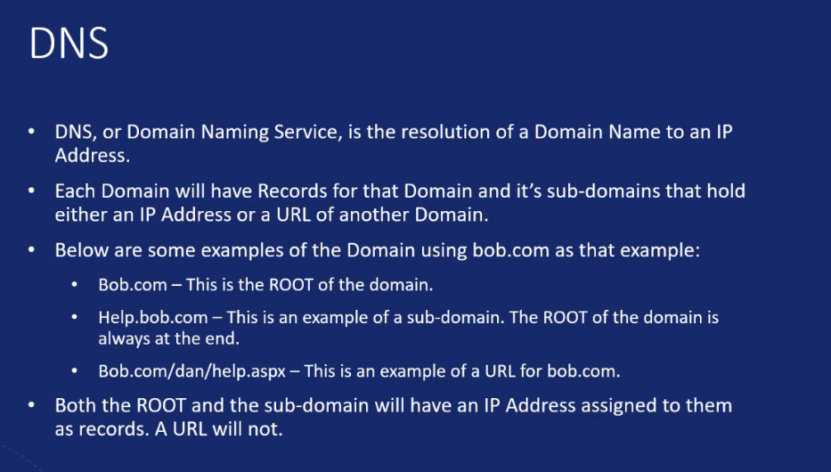

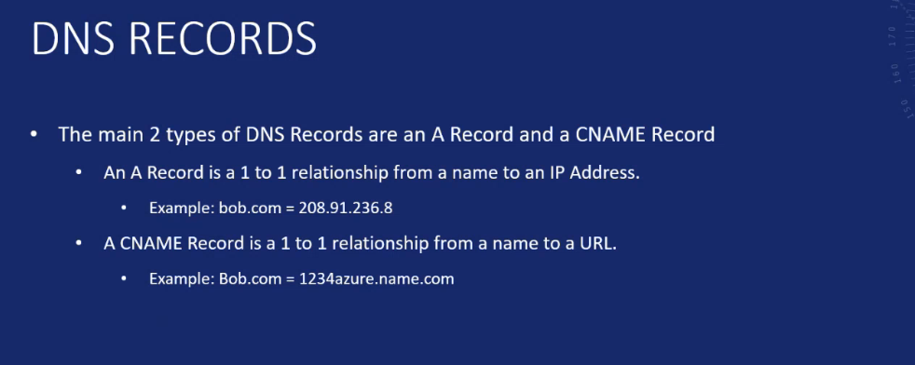

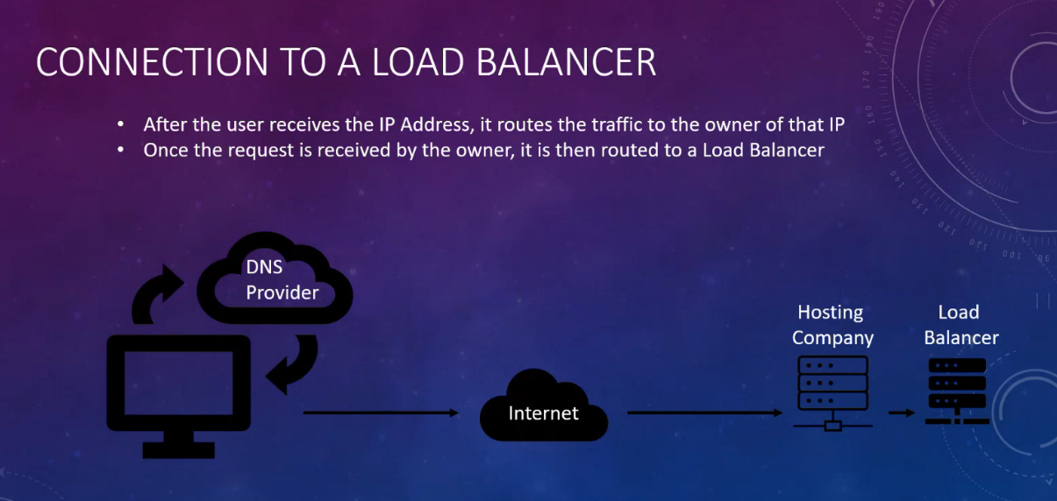

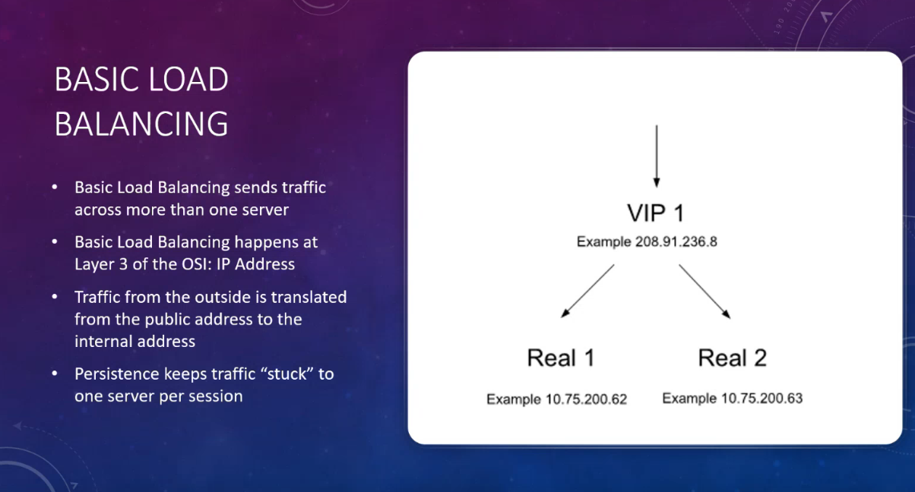

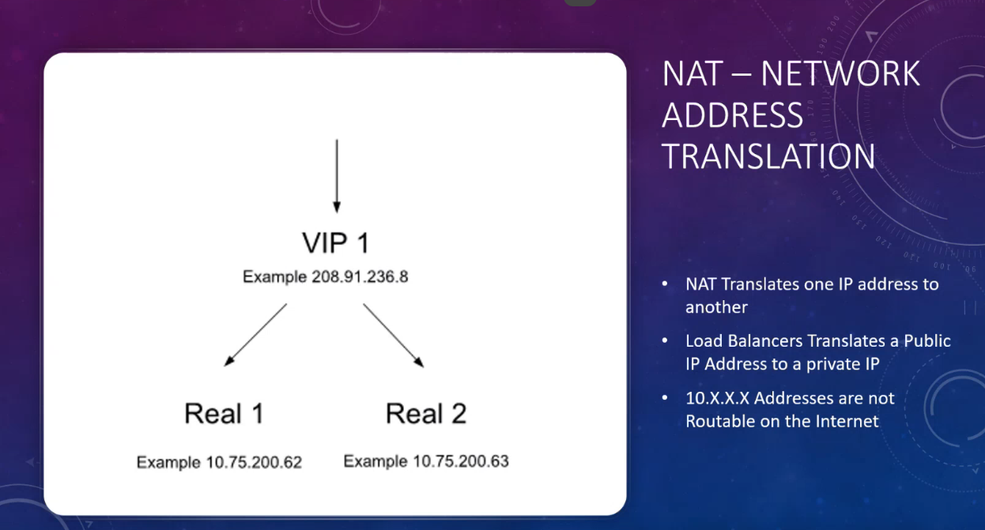

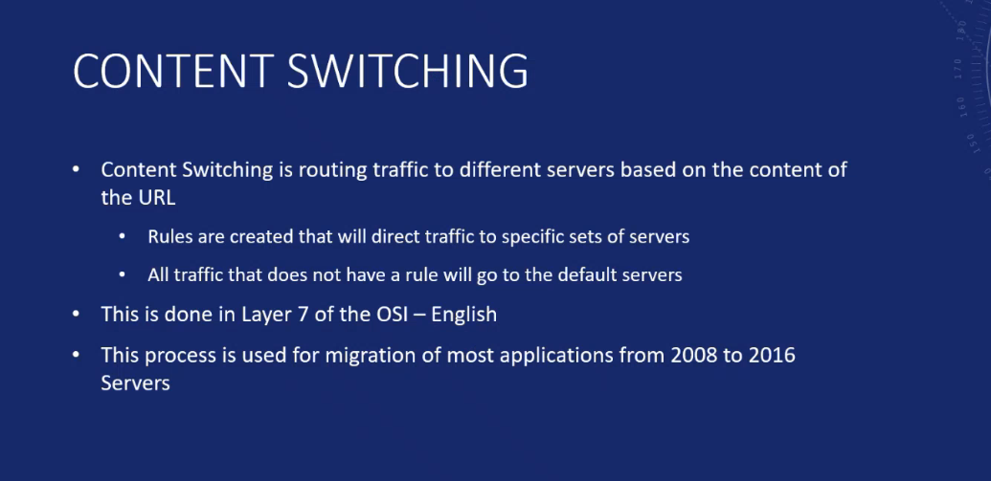

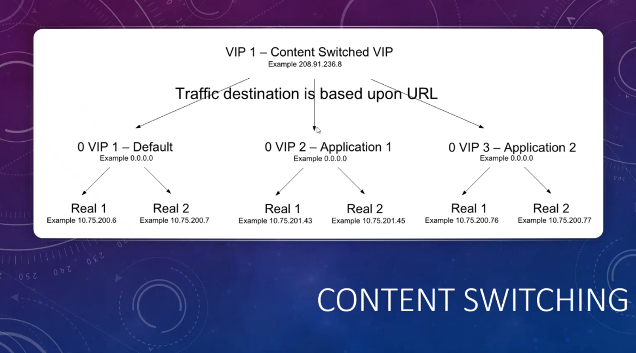

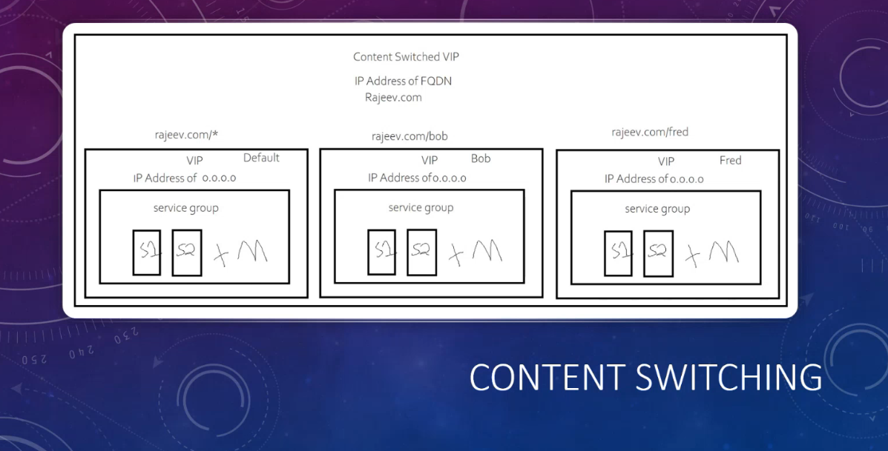

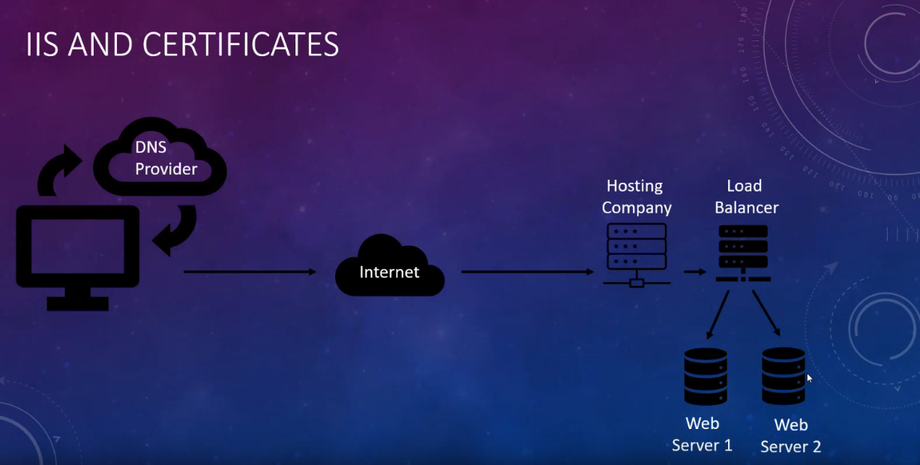

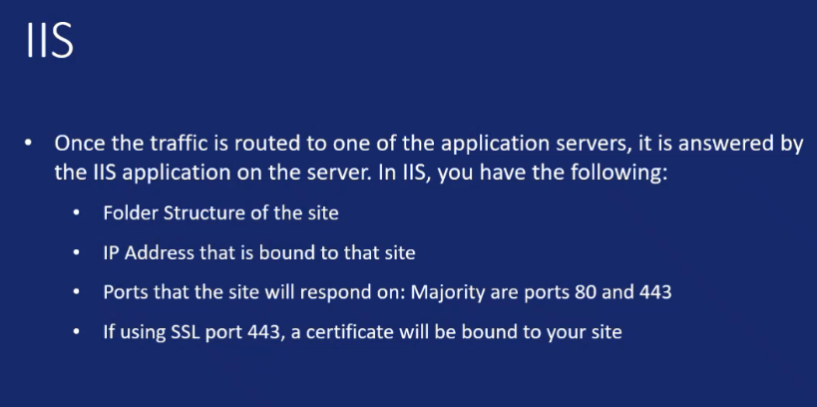

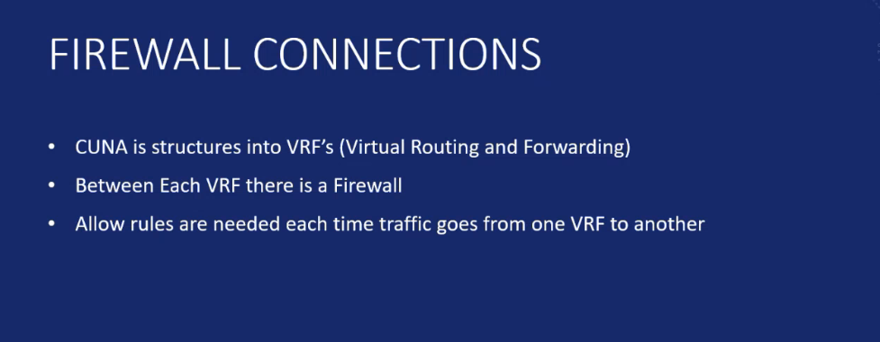

# Summary

The following describes the files you need to add to your ASP.NET Core applications to deploy them to your Atlas AKS cluster. As a member of the application development team, you are responsible for additional configuration and modification of these files to suit your application needs.

You can download the Kubernetes application deployment files from [here](https://dev.azure.com/cunamutual/SecureCloudEnablement/_git/Atlas?path=%2FTools%2FKubernetes&version=GBmaster).

[[_TOC_]]

# Configure Your Project Structure

After downloading a copy of the Kubernetes application deployment, add them to your ASP.NET Core project in a folder called **Kubernetes**.

e.g.,

![image.png](/.attachments/image-f393dce5-1b3a-468f-be47-8d9ecb5ef2dc.png =300x)

# Example Use In Release Pipeline

Two of the files are required to be included in an application release pipeline.

- setup-agent.ps1

- mainAppDeploy.ps1

e.g.,

![image.png](/.attachments/image-1e987864-5004-46ba-99c2-2d6201af06e1.png =400x)

## setup-agent.ps1

Retrieves some information from Azure that is used to populate some pipeline environment variables used for token replacement in the YAML deployment manifest files.

``` powershell

#**********************************************************

# Set RM Service Principal Variables

#**********************************************************

# Get the Account Subscription Id

$SUBSCRIPTION_ID = $(az account show --query id -o tsv)

Write-Verbose "SUBSCRIPTION_ID: $SUBSCRIPTION_ID" -Verbose

Write-Host "##vso[task.setvariable variable=SUBSCRIPTION_ID;]$SUBSCRIPTION_ID"

# Get the Tenant Id in which the Subscription exists

$TENANT_ID = $(az account show --query tenantId -o tsv)

Write-Verbose "TENANT_ID: $TENANT_ID" -Verbose

Write-Host "##vso[task.setvariable variable=TENANT_ID;]$TENANT_ID"

# Get the Subscription Name

$SUBSCRIPTION_NAME = $(az account show --query name -o tsv)

Write-Verbose "SUBSCRIPTION_NAME: $SUBSCRIPTION_NAME" -Verbose

Write-Host "##vso[task.setvariable variable=SUBSCRIPTION_NAME;]$SUBSCRIPTION_NAME"

# Get the name of the user who launched this script

$USER_NAME = $(az account show --query user.name -o tsv)

Write-Verbose "User Name: $USER_NAME" -Verbose

Write-Host "##vso[task.setvariable variable=USER_NAME;]$USER_NAME"

#**********************************************************

# Set Kubernetes Managed Identity Variables

#**********************************************************

# Get Kubernetes Application MI Name and ensure it is lowercase

$K8S_APP_MSI_NAME = $(If ($env:K8S_APP_MSI_NAME) { "$env:K8S_APP_MSI_NAME".ToLower() } Else { Write-Verbose "K8S_APP_MSI_NAME is not defined. AAD Pod Identity will not be deployed." -Verbose })

if ($K8S_APP_MSI_NAME)

{

  # Kubernetes Application MI Name

    Write-Verbose "K8S_APP_MSI_NAME: $K8S_APP_MSI_NAME" -Verbose

  $env:K8S_APP_MSI_NAME = $K8S_APP_MSI_NAME

  Write-Host "##vso[task.setvariable variable=K8S_APP_MSI_NAME;]$K8S_APP_MSI_NAME"

  # Get Kubernetes Application Resource Group Name

  $K8S_APP_RG_NAME = $(If ($env:K8S_APP_RG_NAME) { "$env:K8S_APP_RG_NAME" } Else { Write-Error -Message "ERROR: Missing value for 'K8S_APP_RG_NAME'" -ErrorAction Stop })

  Write-Verbose "K8S_APP_RG_NAME: $K8S_APP_RG_NAME" -Verbose

  # Get Kubernetes Application AAD Pod Identity Selector Name and ensure it is lowercase

  $K8S_APP_AAD_POD_IDENTITY_SELECTOR = "$K8S_APP_MSI_NAME-selector".ToLower()

  Write-Verbose "K8S_APP_AAD_POD_IDENTITY_SELECTOR: $K8S_APP_AAD_POD_IDENTITY_SELECTOR" -Verbose

  $env:K8S_APP_AAD_POD_IDENTITY_SELECTOR = $K8S_APP_AAD_POD_IDENTITY_SELECTOR

  Write-Host "##vso[task.setvariable variable=K8S_APP_AAD_POD_IDENTITY_SELECTOR;]$K8S_APP_AAD_POD_IDENTITY_SELECTOR"

  # Get Kubernetes Application AAD Pod Identity Binding Name and ensure it is lowercase

  $K8S_APP_AAD_POD_IDENTITY_BINDING = "$K8S_APP_MSI_NAME-aad-pod-identity-binding".ToLower()

  Write-Verbose "K8S_APP_AAD_POD_IDENTITY_BINDING: $K8S_APP_AAD_POD_IDENTITY_BINDING" -Verbose

  $env:K8S_APP_AAD_POD_IDENTITY_BINDING = $K8S_APP_AAD_POD_IDENTITY_BINDING

  Write-Host "##vso[task.setvariable variable=K8S_APP_AAD_POD_IDENTITY_BINDING;]$K8S_APP_AAD_POD_IDENTITY_BINDING"

  # Get Kubernetes Application MI Resource ID

  $K8S_APP_MSI_RESOURCE_ID = $(az identity show --resource-group "$K8S_APP_RG_NAME" --name "$K8S_APP_MSI_NAME" --query "id" --output tsv)

  Write-Verbose "K8S_APP_MSI_RESOURCE_ID: $K8S_APP_MSI_RESOURCE_ID" -Verbose

  $env:K8S_APP_MSI_RESOURCE_ID = $K8S_APP_MSI_RESOURCE_ID

  Write-Host "##vso[task.setvariable variable=K8S_APP_MSI_RESOURCE_ID;]$K8S_APP_MSI_RESOURCE_ID"

  # Get Kubernetes Application MI Client Id

  $K8S_APP_MSI_CLIENT_ID = $(az identity show --resource-group "$K8S_APP_RG_NAME" --name "$K8S_APP_MSI_NAME" --query "clientId" --output tsv)

  Write-Verbose "K8S_APP_MSI_CLIENT_ID: $K8S_APP_MSI_CLIENT_ID" -Verbose

  $env:K8S_APP_MSI_CLIENT_ID = $K8S_APP_MSI_CLIENT_ID

  Write-Host "##vso[task.setvariable variable=K8S_APP_MSI_CLIENT_ID;]$K8S_APP_MSI_CLIENT_ID"

}

```

## variables.ps1

Reads pipeline variables to populat PowerShell variables used in the **mainAppDeploy.ps1** script.

**NOTE**: You shold add entries to this file for any variables you require in your application ConfigMap file.

``` powershell

#**********************************************************

# Retrieve values from environment variables (Azure DevOps)

#**********************************************************

$ACR_DOMAIN_NAME = $(If ($env:ACR_DOMAIN_NAME) { "$env:ACR_DOMAIN_NAME" } Else { Write-Error -Message "ERROR: Missing value for 'ACR_DOMAIN_NAME'" -ErrorAction Stop })

Write-Verbose "ACR_DOMAIN_NAME: $ACR_DOMAIN_NAME" -Verbose

$ACR_IMAGE_TAG = $(If ($env:ACR_IMAGE_TAG) { "$env:ACR_IMAGE_TAG" } Else { Write-Error -Message "ERROR: Missing value for 'ACR_IMAGE_TAG'" -ErrorAction Stop })

Write-Verbose "ACR_IMAGE_TAG: $ACR_IMAGE_TAG" -Verbose

$ACR_REPOSITORY_NAME = $(If ($env:ACR_REPOSITORY_NAME) { "$env:ACR_REPOSITORY_NAME" } Else { Write-Error -Message "ERROR: Missing value for 'ACR_REPOSITORY_NAME'" -ErrorAction Stop })

Write-Verbose "ACR_REPOSITORY_NAME: $ACR_REPOSITORY_NAME" -Verbose

$REPOSITORY_IMAGE_NAME = "$ACR_DOMAIN_NAME/$ACR_REPOSITORY_NAME`:$ACR_IMAGE_TAG"

Write-Verbose "REPOSITORY_IMAGE_NAME: $REPOSITORY_IMAGE_NAME" -Verbose

$AKS_NAME = $(If ($env:AKS_NAME) { "$env:AKS_NAME" } Else { Write-Error -Message "ERROR: Missing value for 'AKS_NAME'" -ErrorAction Stop })

Write-Verbose "AKS_NAME: $AKS_NAME" -Verbose

$AKS_RG_NAME = $(If ($env:AKS_RG_NAME) { "$env:AKS_RG_NAME" } Else { Write-Error -Message "ERROR: Missing value for 'AKS_RG_NAME'" -ErrorAction Stop })

Write-Verbose "AKS_RG_NAME: $AKS_RG_NAME" -Verbose

$K8S_NAMESPACE = $(If ($env:K8S_NAMESPACE) { "$env:K8S_NAMESPACE" } Else { Write-Error -Message "ERROR: Missing value for 'K8S_NAMESPACE'" -ErrorAction Stop })

Write-Verbose "K8S_NAMESPACE: $K8S_NAMESPACE" -Verbose

$K8S_APP_NAME = $(If ($env:K8S_APP_NAME) { "$env:K8S_APP_NAME" } Else { Write-Error -Message "ERROR: Missing value for 'K8S_APP_NAME'" -ErrorAction Stop })

Write-Verbose "K8S_APP_NAME: $K8S_APP_NAME" -Verbose

$K8S_APP_ROUTE = $(If ($env:K8S_APP_ROUTE) { "$env:K8S_APP_ROUTE" })

Write-Verbose "K8S_APP_ROUTE: $K8S_APP_ROUTE" -Verbose

$K8S_APP_MSI_NAME = $(If ($env:K8S_APP_MSI_NAME) { "$env:K8S_APP_MSI_NAME" } Else { Write-Verbose -Message "Missing value for 'K8S_APP_MSI_NAME' AAD Pod Identity support will not be deployed." -Verbose })

Write-Verbose "K8S_APP_MSI_NAME: $K8S_APP_MSI_NAME" -Verbose

if ($K8S_APP_MSI_NAME)

{

  $K8S_APP_RG_NAME = $(If ($env:K8S_APP_RG_NAME) { "$env:K8S_APP_RG_NAME" } Else { Write-Error -Message "ERROR: Missing value for 'K8S_APP_RG_NAME'" -ErrorAction Stop })

  Write-Verbose "K8S_APP_RG_NAME: $K8S_APP_RG_NAME" -Verbose

  $K8S_APP_AAD_POD_IDENTITY_SELECTOR = $(If ($env:K8S_APP_AAD_POD_IDENTITY_SELECTOR) { "$env:K8S_APP_AAD_POD_IDENTITY_SELECTOR" } Else { Write-Error -Message "ERROR: Missing value for 'K8S_APP_AAD_POD_IDENTITY_SELECTOR'" -ErrorAction Stop })

  Write-Verbose "K8S_APP_AAD_POD_IDENTITY_SELECTOR: $K8S_APP_AAD_POD_IDENTITY_SELECTOR" -Verbose

  $K8S_APP_AAD_POD_IDENTITY_BINDING = $(If ($env:K8S_APP_AAD_POD_IDENTITY_BINDING) { "$env:K8S_APP_AAD_POD_IDENTITY_BINDING" } Else { Write-Error -Message "ERROR: Missing value for 'K8S_APP_AAD_POD_IDENTITY_BINDING'" -ErrorAction Stop })

  Write-Verbose "K8S_APP_AAD_POD_IDENTITY_BINDING: $K8S_APP_AAD_POD_IDENTITY_BINDING" -Verbose

}

$K8S_APP_KV_NAME = $(If ($env:K8S_APP_KV_NAME) { "$env:K8S_APP_KV_NAME" } Else { Write-Verbose "K8S_APP_MSI_NAME is not defined. Application will not be able to retrieve secrets." -Verbose })

Write-Verbose "K8S_APP_KV_NAME: $K8S_APP_KV_NAME" -Verbose

# Uncomment and add entries for all environment variables specified in the ConfigMap file (sce-app-configmap.yaml)

<#

$DB_SERVER_NAME = $(If ($env:DB_SERVER_NAME) { "$env:DB_SERVER_NAME" } Else { Write-Error -Message "ERROR: Missing value for 'DB_SERVER_NAME'" -ErrorAction Stop })

Write-Verbose "DB_SERVER_NAME: $DB_SERVER_NAME" -Verbose

$DB_NAME = $(If ($env:DB_NAME) { "$env:DB_NAME" } Else { Write-Error -Message "ERROR: Missing value for 'DB_NAME'" -ErrorAction Stop })

Write-Verbose "DB_NAME: $DB_NAME" -Verbose

#>

```

## mainAppDeploy.ps1

Initializes some pipeline environment variables and orchestrates several other PowerShell scripts that deploy the various Kubernetes resources needed to run your application in your Atlas AKS cluster.

Performs the following specifically for your application:

- Gets the PowerSchell script execution path

- Gets information from the Azure Devops RM Service Principal Variables

- Gets you AKS Cluster kubernetes credentials

- Creates a namespace

- Deploys Kubernetes networking policies

- (Optionally) Deploys an AAD Pod Identity configuration

- Deploys an ingress route

- Deploys a Kubernetes ConfigMap (for environment variables)

- Deploys your application as a Kubernetes service

``` powershell

#**********************************************************

# Get PowerSchell Script Execution Path

#**********************************************************

# Get the directory where the main script is executing

$SCRIPT_DIRECTORY = Split-Path -Path $MyInvocation.MyCommand.Definition -Parent

Write-Verbose "Script Directory: $SCRIPT_DIRECTORY" -Verbose

#**********************************************************

# Get Azure Devops RM Service Principal Variables

#**********************************************************

# Get the Account Subscription Id

$SUBSCRIPTION_ID = $(az account show --query id -o tsv)

Write-Verbose "SUBSCRIPTION_ID: $SUBSCRIPTION_ID" -Verbose

# Get the Tenant Id in which the Subscription exists

$TENANT_ID = $(az account show --query tenandId -o tsv)

Write-Verbose "TENANT_ID: $TENANT_ID" -Verbose

# Get the Subscription Name

$SUBSCRIPTION_NAME = $(az account show --query name -o tsv)

Write-Verbose "SUBSCRIPTION_NAME: $SUBSCRIPTION_NAME" -Verbose

# Get the name of the user who launched this script

$USER_NAME = $(az account show --query user.name -o tsv)

Write-Verbose "User Name: $USER_NAME" -Verbose

#**********************************************************

# Get Azure DevOps Release Pipeline Variables

#**********************************************************

. (Join-Path $SCRIPT_DIRECTORY "variables.ps1")

#**********************************************************

# Set location for creating kubernetes config file

#**********************************************************

# Relative path for kube config file

$KUBE_CONFIG_PATH = [IO.Path]::Combine($env:USERPROFILE, ".kube", "config")

Write-Verbose "KUBE_CONFIG_PATH: $KUBE_CONFIG_PATH" -Verbose

#**********************************************************

# Get AKS Cluster kubernetes credentials as admininstrator

#**********************************************************

try {

    Write-Verbose "Get credentials and set up for kubectl to use" -Verbose

    az aks get-credentials -g "$AKS_RG_NAME" `

        -n "$AKS_NAME" -a -f "$KUBE_CONFIG_PATH"

    Write-Verbose "Get kubectl version info" -Verbose

    kubectl --kubeconfig "$KUBE_CONFIG_PATH" version short

}

catch {

    $ERROR_MESSAGE = $_.Exception.Message

    Write-Verbose "Error while getting credentials and set up for kubectl to use: " -Verbose

    Write-Error -Message "ERROR: $ERROR_MESSAGE" -ErrorAction Stop

}

#**********************************************************

# Create namespace

#**********************************************************

. (Join-Path $SCRIPT_DIRECTORY "createNamespace.ps1")

#**********************************************************

# Deploy Network Policies

#**********************************************************

. (Join-Path $SCRIPT_DIRECTORY "deployNetworkPolicies.ps1")

#**********************************************************

# Deploy app permission, routes and services

#**********************************************************

if ($K8S_APP_MSI_NAME)

{

  . (Join-Path $SCRIPT_DIRECTORY "deployAadPodIdentity.ps1")

}

. (Join-Path $SCRIPT_DIRECTORY "deployAppIngressRoutes.ps1")

. (Join-Path $SCRIPT_DIRECTORY "deployConfigMap.ps1")

. (Join-Path $SCRIPT_DIRECTORY "deployAppService.ps1")

#**********************************************************

# Delete the kubernetes config file

#**********************************************************

if ("true" -eq "$(Test-Path -Path "$KUBE_CONFIG_PATH")".ToLower()) {

    Write-Verbose "Removing kubectl config file" -Verbose

    Remove-Item –path "$KUBE_CONFIG_PATH"

}

else {

    Write-Verbose "kubectl config file does not exist" -Verbose

}

```

# Create a Namespace

## createNamespace.ps1

Deploys a Kubernetes namespace for your application.

``` powershell

#**********************************************************

# Create K8s namespace

#**********************************************************

try {

    Write-Verbose "Creating Namespace" -Verbose

    # Get K8s manifest file path

    $AKS_CREATE_NAMESPACE_FILE = (Join-Path $SCRIPT_DIRECTORY "sce-create-namespace.yaml")

    Write-Verbose "AKS_CREATE_NAMESPACE_FILE: $AKS_CREATE_NAMESPACE_FILE" -Verbose

    # Show the the manifest file contents

    Write-Verbose "Contents of $AKS_CREATE_NAMESPACE_FILE :" -Verbose

    Write-Verbose (Get-Content -Path $AKS_CREATE_NAMESPACE_FILE | Out-String) -Verbose

    kubectl --kubeconfig "$KUBE_CONFIG_PATH" apply -f $AKS_CREATE_NAMESPACE_FILE

    Write-Verbose "Successfully Created Namespace" -Verbose

}

catch {

    $ERROR_MESSAGE = $_.Exception.Message

    Write-Verbose "Error while creating Namespace: " -Verbose

    Write-Error -Message "ERROR: $ERROR_MESSAGE" -ErrorAction Stop

}

```

## sce-create-namespace.yaml

YAML manifest file used when creating the application namespace.

``` yaml

apiVersion: v1

kind: Namespace

metadata:

  name: __K8S_NAMESPACE__

  labels:

    name: __K8S_NAMESPACE__

```

# Deploy Kubernetes Networking Policies

By default, the following Kubernetes networking policies will be applied to the specified namespace:

- Denies all traffic from accessing any and all services (pods) running in your K8s namespace. (**sce-network-policy-app-deny-all.yaml**)

- Overrides the deny policy to allow all incoming traffic (external to the cluster) coming from the NGINX ingress controller namespace to your K8s app namespace. (**sce-network-policy-allow-external.yaml**)

## Securing Kubernetes with Network Policies

For more information on securing Kubernetes with network policies, see the following:

- [Securing Kubernetes Cluster Networking](https://ahmet.im/blog/kubernetes-network-policy/)

- [Kubernetes Network Policy Recipes](https://github.com/ahmetb/kubernetes-network-policy-recipes)

- [Kubernetes - Network Policies](https://kubernetes.io/docs/concepts/services-networking/network-policies/)

## deployNetworkPolicies.ps1

Deploys Kubernetes networking policies for your application that do the following:

``` yaml

#**********************************************************

# Deploy the Deny All App Network Policy

#**********************************************************

try {

    Write-Verbose "Deploying App Network Policy - Deny All Traffic Into Namespace" -Verbose

    # Get K8s manifest file path

    $NETWORK_POLICY_DENY_ALL_FILE = (Join-Path $SCRIPT_DIRECTORY "sce-network-policy-app-deny-all.yaml")

    Write-Verbose "NETWORK_POLICY_DENY_ALL_FILE: $NETWORK_POLICY_DENY_ALL_FILE" -Verbose

    # Show the the manifest file contents

    Write-Verbose "Contents of $NETWORK_POLICY_DENY_ALL_FILE :" -Verbose

    Write-Verbose (Get-Content -Path $NETWORK_POLICY_DENY_ALL_FILE | Out-String) -Verbose

    kubectl --kubeconfig "$KUBE_CONFIG_PATH" apply -f $NETWORK_POLICY_DENY_ALL_FILE

    Write-Verbose "Successfully Deployed App Network Policy - Deny All Traffic Into Namespace" -Verbose

}

catch {

    $ERROR_MESSAGE = $_.Exception.Message

    Write-Verbose "Error while deploying App Network Policy - Deny All Traffic Into Namespace: " -Verbose

    Write-Error -Message "ERROR: $ERROR_MESSAGE" -ErrorAction Stop

}

#**********************************************************

# Deploy the Allow External App Network Policy

#**********************************************************

try {

    Write-Verbose "Deploying App Network Policy - Allow All Traffic From Ingress Controller Into Namespace" -Verbose

    # Get K8s manifest file path

    $NETWORK_POLICY_ALLOW_INGRESS_NGINX_5000_FILE = (Join-Path $SCRIPT_DIRECTORY "sce-network-policy-allow-external.yaml")

    Write-Verbose "NETWORK_POLICY_ALLOW_INGRESS_NGINX_5000_FILE: $NETWORK_POLICY_ALLOW_INGRESS_NGINX_5000_FILE" -Verbose

    # Show the the manifest file contents

    Write-Verbose "Contents of $NETWORK_POLICY_ALLOW_INGRESS_NGINX_5000_FILE :" -Verbose

    Write-Verbose (Get-Content -Path $NETWORK_POLICY_ALLOW_INGRESS_NGINX_5000_FILE | Out-String) -Verbose

    kubectl --kubeconfig "$KUBE_CONFIG_PATH" apply -f $NETWORK_POLICY_ALLOW_INGRESS_NGINX_5000_FILE

    Write-Verbose "Successfully Deployed App Network Policy - Allow All Traffic From Ingress Controller Into Namespace" -Verbose

}

catch {

    $ERROR_MESSAGE = $_.Exception.Message

    Write-Verbose "Error while deploying App Network Policy - Allow All Traffic From Ingress Controller Into Namespace: " -Verbose

    Write-Error -Message "ERROR: $ERROR_MESSAGE" -ErrorAction Stop

}

```

## sce-network-policy-app-deny-all.yaml

YAML manifest file which defines a networking policy to deny all traffic from accessing any and all services (pods) running in your K8s namespace.

``` yaml

# DENY all non-whitelisted traffic to a namespace

kind: NetworkPolicy

apiVersion: networking.k8s.io/v1

metadata:

  name: __K8S_NAMESPACE__-deny-all

  namespace: __K8S_NAMESPACE__

spec:

  podSelector: {}

  ingress: []

```

## sce-network-policy-allow-external.yaml

YAML manifest file which defines a networking policy that overrides the deny policy to allow all incoming traffic (external to the cluster) coming from the NGINX ingress controller namespace to your K8s app namespace.

``` yaml

# ALLOW traffic from the ingress controller namespace

kind: NetworkPolicy

apiVersion: networking.k8s.io/v1

metadata:

  name: __K8S_APP_NAME__-allow-external

  namespace: __K8S_NAMESPACE__

spec:

  podSelector:

    matchLabels:

      app: __K8S_APP_NAME__

  policyTypes:

  - Ingress

  ingress:

  - from:

    - namespaceSelector:

        matchLabels:

          name: ingress-nginx

```

# Optional Kubernetes Networking Policies

In addition to the default kubernetes networking configuration, you may choose to allow some additional access to services (pods) running in other namespaces or withing the same namespace. If you choose to implement any of the following, you must extend the code in the deployNetworkPolicies.ps1 PowerShell script to deploy any additional network policies you require. the following are some example YAML manifest you could use in your application release pipeline.

## sce-network-policy-allow-all-from-other-namespace.yaml

YAML manifest file which defines a networking policy that overrides the deny policy to allow traffic from another specified namespace in the same Kubernetes cluster.

``` yaml

# ALLOW all traffic from a matched namespace

kind: NetworkPolicy

apiVersion: networking.k8s.io/v1

metadata:

  name: __K8S_APP_NAME__-allow-other-namespace

  namespace: __K8S_NAMESPACE__

spec:

  podSelector:

    matchLabels:

      app: __K8S_APP_NAME__

  ingress:

  - from:

    - namespaceSelector:

        matchLabels:

          name: __K8S_OTHER_NAMESPACE__

```

## sce-network-policy-app-deny-all.yaml

YAML manifest file which defines a networking policy that deny all traffic to a specific application in your K8s namespace.

``` yaml

# DENY all traffic to an application

kind: NetworkPolicy

apiVersion: networking.k8s.io/v1

metadata:

  name: __K8S_APP_NAME__-deny-all

  namespace: __K8S_NAMESPACE__

spec:

  podSelector:

    matchLabels:

      app: __K8S_APP_NAME__

  ingress: []

```

## sce-network-policy-app-allow-from-other-app.yaml

YAML manifest file which defines a networking policy that overrides the deny policy to allow traffic from another service (pod) running in the same namespace.

``` yaml

# LIMIT traffic from another application

kind: NetworkPolicy

apiVersion: networking.k8s.io/v1

metadata:

  name: __K8S_APP_NAME__-app-allow

  namespace: __K8S_NAMESPACE__

spec:

  podSelector:

    matchLabels:

      app: __K8S_APP_NAME__

  ingress:

  - from:

      - podSelector:

          matchLabels:

            app: __K8S_OTHER_APP_NAME__

```

# Deploy Azure Active Directory (AAD) Pod Identity Configuration

For more information about AAD Pod Identity, see:

[AAD Pod Identity](https://github.com/Azure/aad-pod-identity/blob/master/README.md)

[Kubernetes Applications With Azure Active Directory Identities](https://azure.github.io/aad-pod-identity/docs/demo/standard_walkthrough/)

## deployAadPodIdentity.ps1

Deploys the following resources:

**azureIdentity**

A custom resource definition object that represents either:

- User-Assigned Service Identity (MSI)

- Service Principal (N/A at CMFG)

**azureIdentityBinding**

A custom resource definition object used to describe azureIdentity is assigned to pod.

**azureAssignedIdentity**

A custom resource definition object. Each instance represents linking a pod to its azureIdentity.

``` powershell

#**********************************************************

# Deploy K8s Application AAD Pod Identity

#**********************************************************

try {

    Write-Verbose "Deploying K8s Application AAD Pod Identity" -Verbose

    # Get K8s manifest file path

    $AAD_POD_IDENTITY_FILE_PATH = (Join-Path $SCRIPT_DIRECTORY "aad-pod-identity.yaml")

    Write-Verbose "AAD_POD_IDENTITY_FILE_PATH: $AAD_POD_IDENTITY_FILE_PATH" -Verbose

    # Show the the manifest file contents

    Write-Verbose "Contents of $AAD_POD_IDENTITY_FILE_PATH :" -Verbose

    Write-Verbose (Get-Content -Path $AAD_POD_IDENTITY_FILE_PATH | Out-String) -Verbose

    kubectl --kubeconfig "$KUBE_CONFIG_PATH" apply -f $AAD_POD_IDENTITY_FILE_PATH

    Write-Verbose "Successfully Deployed K8s Application AAD Pod Identity" -Verbose

}

catch {

    $ERROR_MESSAGE = $_.Exception.Message

    Write-Verbose "Error while deploying K8s Application AAD Pod Identity: " -Verbose

    Write-Error -Message "ERROR: $ERROR_MESSAGE" -ErrorAction Stop

}

#**********************************************************

# Deploy K8s Application AAD Pod Identity Binding

#**********************************************************

try {

    Write-Verbose "Deploying K8s Application AAD Pod Identity Binding" -Verbose

    # Get K8s manifest file path

    $AAD_POD_IDENTITY_BINDING_FILE_PATH = (Join-Path $SCRIPT_DIRECTORY "aad-pod-identity-binding.yaml")

    Write-Verbose "AAD_POD_IDENTITY_BINDING_FILE_PATH: $AAD_POD_IDENTITY_BINDING_FILE_PATH" -Verbose

    # Show the the manifest file contents

    Write-Verbose "Contents of $AAD_POD_IDENTITY_BINDING_FILE_PATH :" -Verbose

    Write-Verbose (Get-Content -Path $AAD_POD_IDENTITY_BINDING_FILE_PATH | Out-String) -Verbose

    kubectl --kubeconfig "$KUBE_CONFIG_PATH" apply -f $AAD_POD_IDENTITY_BINDING_FILE_PATH

    Write-Verbose "Successfully Deployed K8s Application AAD Pod Identity Binding" -Verbose

}

catch {

    $ERROR_MESSAGE = $_.Exception.Message

    Write-Verbose "Error while deploying K8s Application AAD Pod Identity Binding: " -Verbose

    Write-Error -Message "ERROR: $ERROR_MESSAGE" -ErrorAction Stop

```

## aad-pod-identity.yaml

YAML manifest file which defines an **AzureIdentity** resource for your app in the app namespace.

``` yaml

apiVersion: "aadpodidentity.k8s.io/v1"

kind: AzureIdentity

metadata:

  name: __K8S_APP_MSI_NAME__

  namespace: __K8S_NAMESPACE__

  annotations:

    aadpodidentity.k8s.io/Behavior: namespaced

spec:

  type: 0

  resourceID: __K8S_APP_MSI_RESOURCE_ID__

  clientID: __K8S_APP_MSI_CLIENT_ID__

```

## aad-pod-identity-binding.yaml

YAML manifest file which defines an **AzureIdentityBinding** resource for your app in the app namespace. The **__K8S_APP_AAD_POD_IDENTITY_SELECTOR__** variable token must included as a value for the **aadpodidbinding** label (which you may need to uncomment) in your application deployment manifest file (**sce-deploy-app.yaml**).

``` yaml

apiVersion: "aadpodidentity.k8s.io/v1"

kind: AzureIdentityBinding

metadata:

  name: __K8S_APP_AAD_POD_IDENTITY_BINDING__

  namespace: __K8S_NAMESPACE__

spec:

  azureIdentity: __K8S_APP_MSI_NAME__

  selector: __K8S_APP_AAD_POD_IDENTITY_SELECTOR__

```

# Deploy Application Ingress Route

## deployAppIngressRoutes.ps1

Deploys an NGINX ingress route to enable the controller to route incoming traffic to your application running in the specified namespace.

WARNING: services NEED to be in the same namespace as the ingress, otherwise you'll get a 503 error.

``` powershell

#**********************************************************

# Deploy the application route(s) for ingress controller

#**********************************************************

if (($K8S_APP_ROUTE) -and ($K8S_APP_ROUTE.length -gt 0)) {

    Write-Verbose "Found a value defined for the 'K8S_APP_ROUTE' variable" -Verbose

    try {

        Write-Verbose "Deploying Ingress Route" -Verbose

        # Get K8s manifest file path

        $AKS_DEPLOY_INGRESS_ROUTE_FILE = (Join-Path $SCRIPT_DIRECTORY "sce-ingress-routes.yaml")

        Write-Verbose "AKS_DEPLOY_INGRESS_ROUTE_FILE: $AKS_DEPLOY_INGRESS_ROUTE_FILE" -Verbose

        # Show the the manifest file contents

        Write-Verbose "Contents of $AKS_DEPLOY_INGRESS_ROUTE_FILE :" -Verbose

        Write-Verbose (Get-Content -Path $AKS_DEPLOY_INGRESS_ROUTE_FILE | Out-String) -Verbose

        kubectl --kubeconfig "$KUBE_CONFIG_PATH" apply -f $AKS_DEPLOY_INGRESS_ROUTE_FILE

        Write-Verbose "Successfully Deployed Ingress Route" -Verbose

    }

    catch {

        $ERROR_MESSAGE = $_.Exception.Message

        Write-Verbose "Error while deploying app: " -Verbose

        Write-Error -Message "ERROR: $ERROR_MESSAGE" -ErrorAction Stop

    }

}

```

## sce-ingress-routes.yaml

YAML manifest file which defines how to route incoming traffic to the specified service running in your namespace.

``` yaml

apiVersion: extensions/v1beta1

kind: Ingress

metadata:

  name: __K8S_APP_NAME__-route

  namespace: __K8S_NAMESPACE__

  annotations:

    kubernetes.io/ingress.class: nginx

    nginx.ingress.kubernetes.io/rewrite-target: /

spec:

#services NEED to be in the same namespace as the ingress, otherwise you'll get a 503

  rules:

  - http:

      paths:

      - path: __K8S_APP_ROUTE__

        backend:

          serviceName: __K8S_APP_NAME__

          servicePort: 80

```

# Deploy Kubernetes ConfigMap

## deployConfigMap.ps1

Deploys a Kubernetes ConfigMap resource for your application running in the specified namespace.

**NOTE**: This is the file where you should add entries to define the values you would normally put into appsetting.json.

``` powershell

#**********************************************************

# Deploy the application ConfigMap

#**********************************************************

try {

    Write-Verbose "Deploying App ConfigMap" -Verbose

    # Get K8s manifest file path

    $AKS_DEPLOY_CONFIGMAP_FILE = (Join-Path $SCRIPT_DIRECTORY "sce-app-configmap.yaml")

    Write-Verbose "AKS_DEPLOY_CONFIGMAP_FILE: $AKS_DEPLOY_CONFIGMAP_FILE" -Verbose

    # Show the the manifest file contents

    Write-Verbose "Contents of $AKS_DEPLOY_CONFIGMAP_FILE :" -Verbose

    Write-Verbose (Get-Content -Path $AKS_DEPLOY_CONFIGMAP_FILE | Out-String) -Verbose

    kubectl --kubeconfig "$KUBE_CONFIG_PATH" apply -f $AKS_DEPLOY_CONFIGMAP_FILE

    Write-Verbose "Successfully Deployed App ConfigMap" -Verbose

}

catch {

    $ERROR_MESSAGE = $_.Exception.Message

    Write-Verbose "Error while deploying App ConfigMap: " -Verbose

    Write-Error -Message "ERROR: $ERROR_MESSAGE" -ErrorAction Stop

}

```

## sce-app-configmap.yaml

YAML manifest file which defines the environment specific variables used by your application.

``` yaml

apiVersion: v1

kind: ConfigMap

metadata:

  name: __K8S_APP_NAME__-configmap

  namespace: __K8S_NAMESPACE__

data:

  APPINSIGHTS_INSTRUMENTATIONKEY: "__APPINSIGHTS_INSTRUMENTATIONKEY__"

  AspNetCorePathBase: "__K8S_APP_ROUTE__"

  TenantId: "__TENANT_ID__"

  KeyVaultName: "__K8S_APP_KV_NAME__"

  DbServerName: "__DB_SERVER_NAME__"

  DbName: "__DB_NAME__"

```

# Deploy application as a Kubernetes service

## deployAppService.ps1

``` powershell

#**********************************************************

# Deploy the application service

#**********************************************************

try {

    Write-Verbose "Deploying App Service" -Verbose

    # Get K8s manifest file path

    $AKS_DEPLOY_APP_FILE = (Join-Path $SCRIPT_DIRECTORY "sce-deploy-app.yaml")

    Write-Verbose "AKS_DEPLOY_APP_FILE: $AKS_DEPLOY_APP_FILE" -Verbose

    # Show the the manifest file contents

    Write-Verbose "Contents of $AKS_DEPLOY_APP_FILE :" -Verbose

    Write-Verbose (Get-Content -Path $AKS_DEPLOY_APP_FILE | Out-String) -Verbose

    kubectl --kubeconfig "$KUBE_CONFIG_PATH" apply -f $AKS_DEPLOY_APP_FILE

    Write-Verbose "Successfully Deployed App Service" -Verbose

}

catch {

    $ERROR_MESSAGE = $_.Exception.Message

    Write-Verbose "Error while deploying App Service: " -Verbose

    Write-Error -Message "ERROR: $ERROR_MESSAGE" -ErrorAction Stop

}

```

## sce-deploy-app.yam

``` yaml

---

apiVersion: apps/v1

kind: Deployment

metadata:

  name: __K8S_APP_NAME__

  namespace: __K8S_NAMESPACE__

  labels:

    app: __K8S_APP_NAME__

spec:

  selector:

    matchLabels:

      app: __K8S_APP_NAME__

  template:

    metadata:

      labels:

        app: __K8S_APP_NAME__

        # Uncomment the following if you use AAD Pod Identity

        # aadpodidbinding: __K8S_APP_AAD_POD_IDENTITY_SELECTOR__

    spec:

      containers:

      - name: __K8S_APP_NAME__

        image: __REPOSITORY_IMAGE_NAME__

        imagePullPolicy: Always

        resources:

          requests:

            cpu: 100m

            memory: 100Mi

          limits:

            cpu: 200m

            memory: 200Mi

        ports:

        - containerPort: 80

        envFrom:

          - configMapRef:

              name: __K8S_APP_NAME__-configmap

---

apiVersion: v1

kind: Service

metadata:

  name: __K8S_APP_NAME__

  namespace: __K8S_NAMESPACE__

  labels:

    app: __K8S_APP_NAME__

spec:

  type: ClusterIP

  ports:

  - port: 80

    targetPort: 5000

  selector:

    app: __K8S_APP_NAME__

---

apiVersion: autoscaling/v1

kind: HorizontalPodAutoscaler

metadata:

  name: __K8S_APP_NAME__-hpa

  namespace: __K8S_NAMESPACE__

  labels:

    app: __K8S_APP_NAME__

spec:

  scaleTargetRef:

    apiVersion: apps/v1

    kind: Deployment

    name: __K8S_APP_NAME__

  minReplicas: 2

  maxReplicas: 5

  targetCPUUtilizationPercentage: 80

```

# Run Application Deployment Locally

## az-login.ps1

# Required for workstations running Netskope

$cacertFile = 'C:\certs\cacert.pem'

# Tells Netskope where to find you

$env:REQUESTS_CA_BUNDLE = $cacertFile

[System.Environment]::SetEnvironmentVariable("KUBECONFIG", $ENV:USERPROFILE +"\.kube\config" , "User")

# Relative path for kube config file

$KUBE_CONFIG_PATH = "$env:KUBECONFIG"

Write-Verbose "KUBE_CONFIG_PATH: $KUBE_CONFIG_PATH" -Verbose

# Before you begin - make sure you're logged into Azure using the Azure CLI

az login

# Ensure you specify your Azure subscription

# (if you have more than one subscription)

$SUBSCRIPTION_NAME = "CMFG-Sandbox"

Write-Verbose "Set the default Azure subscription" -Verbose

az account set --subscription "$SUBSCRIPTION_NAME"

$SUBSCRIPTION_ID = $(az account show --query id -o tsv)

Write-Verbose "SUBSCRIPTION_ID: $SUBSCRIPTION_ID" -Verbose

$SUBSCRIPTION_NAME = $(az account show --query name -o tsv)

Write-Verbose "SUBSCRIPTION_NAME: $SUBSCRIPTION_NAME" -Verbose

$USER_NAME = $(az account show --query user.name -o tsv)

Write-Verbose "Service Principal Name or ID: $USER_NAME" -Verbose

$TENANT_ID = $(az account show --query tenantId -o tsv)

Write-Verbose "TENANT_ID: $TENANT_ID" -Verbose

# Tell PowerShell where it can find your Azure CLI

$env:path += ";C:\Program Files\Git\mingw64\bin;"

#**********************************************************

# Get this script's execution path

#**********************************************************

$SCRIPT_DIRECTORY = ($pwd).path

Write-Verbose "SCRIPT_DIRECTORY: $SCRIPT_DIRECTORY" -Verbose

$KUBERNETES_PATH = Join-Path $SCRIPT_DIRECTORY "AspNetCore30WebApi/Kubernetes"

Write-Verbose "KUBERNETES_PATH: $KUBERNETES_PATH" -Verbose

$SCRIPT_DIRECTORY = $KUBERNETES_PATH

#**********************************************************

# (Optional) Build a local container and run it

#**********************************************************

# Get AKS Cluster Credentials

# Enter your AKS Cluster resource group and name in the following statement

az aks get-credentials --resource-group "RG-" --name "AKS-" -f "$KUBE_CONFIG_PATH"

Write-Verbose "Get kubectl version info"

kubectl --kubeconfig "$KUBE_CONFIG_PATH" version short

# The following kubectl command can be used to pin your session to

# a specific namespace in your kubernetes cluster.

# IMPORTANT: Read the following:

# For the statement below, 'your_k8s_namespace' is only meant to be a placeholder

# You must replace it with your desired kubernetes namespace name

kubectl config set-context --current --namespace=your-namespace

# Stop all containers:

docker stop $(docker ps -aq)

# Remove all containers

docker rm $(docker ps -aq)

# Set variables for local docker container tests

$IMAGE_NAME = "aspnetcore30webapi"

$IMAGE_TAG = "v1.0.0"

$CONTAINER_NAME = "$IMAGE_NAME`:$IMAGE_TAG"

Write-Verbose "CONTAINER_NAME: $CONTAINER_NAME" -Verbose

$DOCKERFILE_DIRECTORY = (Join-Path ($pwd).path "AspNetCore30WebApi")

Write-Verbose "DOCKERFILE_DIRECTORY: $DOCKERFILE_DIRECTORY" -Verbose

$DOCKERFILE_PATH = (Join-Path "$DOCKERFILE_DIRECTORY" "Dockerfile")

Write-Verbose "DOCKERFILE_PATH: $DOCKERFILE_PATH" -Verbose

# List all images

docker images -a

# Remove any previous image

docker rmi -f "$CONTAINER_NAME"

# Remove dangling images

docker images -f dangling=true

# Build the container

docker build -f $DOCKERFILE_PATH -t "$CONTAINER_NAME" .

# Run the image:cd

docker run -p 5000:5000 "$CONTAINER_NAME"

# Test the containerized application is working:

# http://localhost:5000/api/weatherforcast

```